Ice Breaker:

If you can be a person in an existing or fictional computer game, who do you want to be?

~ 2 -3 minutes thinking time

Retro:

TH: unified 
AS 
him 

**Florian**: Contact Thomas R. about contract status with WTC and Sneha, so that WTC should not assign tickets to Sneha any more

**Florian**: Get Dev Environment up and running

**Thomas**: Create invitation for preparations

**Abhi**: Make thoughts about a unified calendar to have a shared calendar system where everyone can put its absence in it

**Scrum Team:** Create tickets for every task

How is your mood? - Talking about how is your mood at the moment

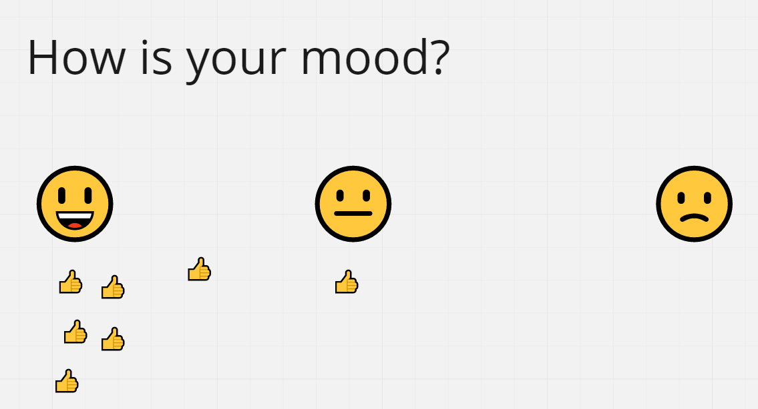

Ice Breaker:

What is your favorite "thing"

* A "thing" could be a hobby, an animal, a meme, or just a favorite "thing" you do at work
* Search for an according image on the web
* Tell us why you choose this image
* Duration for finding your favorite "thing": 5 minutes

**Mad – Sad – Glad**

**Thomas:** Create Reportings for Scrum Team

Ice Breaker:

Does your family have any holiday traditions at Christmas?

As the Indian colleagues are not celebrating Christmas, how are they nevertheless influenced by Christmas?

Christmas Ice Breaker 
your family have any holiday traditions? / 
Indian colleagues; Are you influenced by Christmas? 
Like eating some special meab5, travelling, visiting family, going to church.... 
• g minutes thinking time 

Retro: I LIKE, I WISH, I WONDER

Ice Breaker:

Our team with Emojis.

Retro: Retro in the island of OneWeb

Ice Breaker:

Virtual Icon Hunt

Retro: That, what needs to be said

